1.Create Table Name: Student and Exam

* Create Student Table Queries

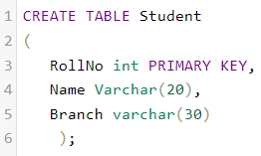

* Create Exam Table Queries

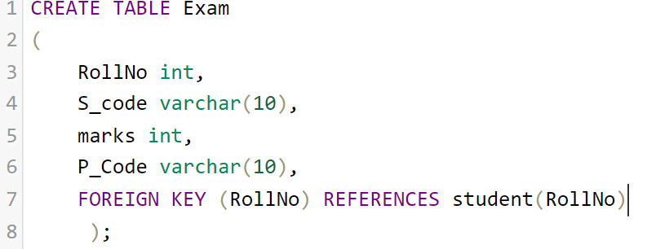

* Student Insert Query

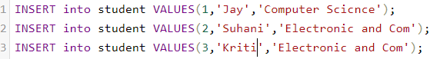

* Exam Insert Query

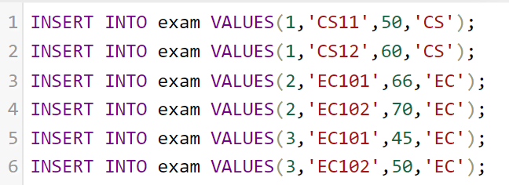

* Student Table

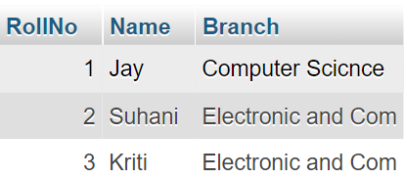

* Exam Table

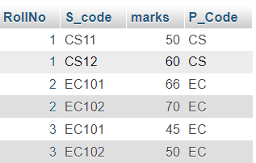

2. Create table given below: Employee and Incentive Table

* Employee Table

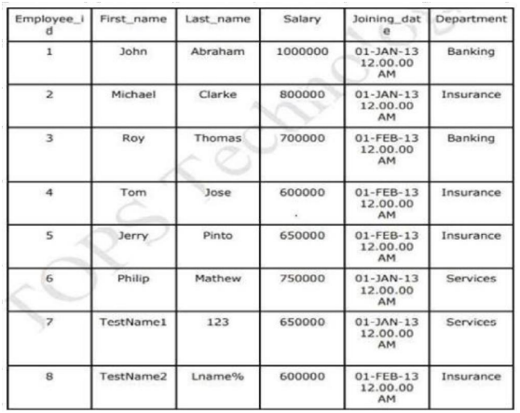

* Incentive Table

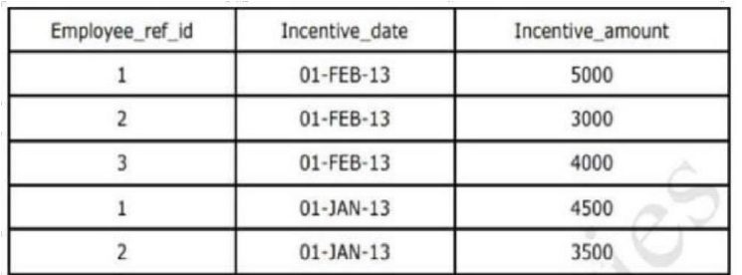

* Create Employee Table Queries

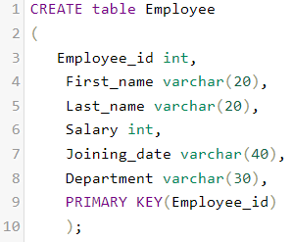

* Create Incentive Table Queries

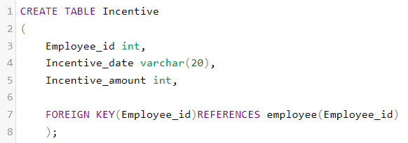

* Employee Insert Query

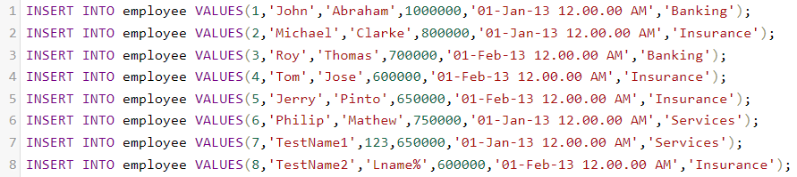

* Incentive Insert Query

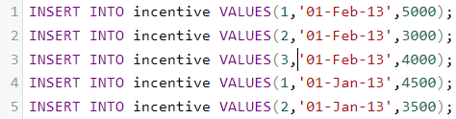

* Employee Table

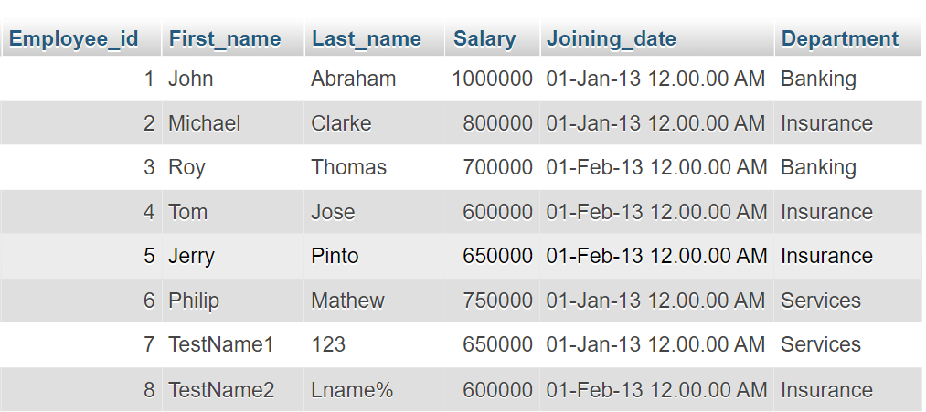

* Incentive Table

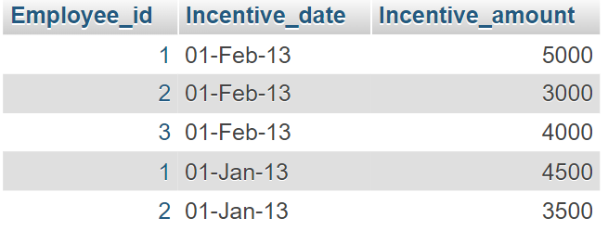

3. Get First_Name from employee table using Tom name “Employee Name”.

Ans: 

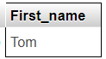

4. Get FIRST_NAME, Joining Date, and Salary from employee table.

Ans:



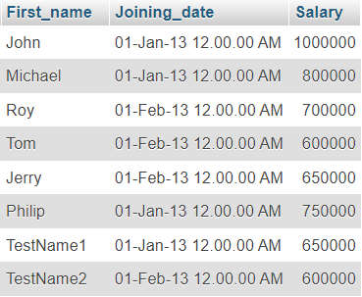

5. Get all employee details from the employee table order by First_Name Ascending and Salary descending?

Ans:



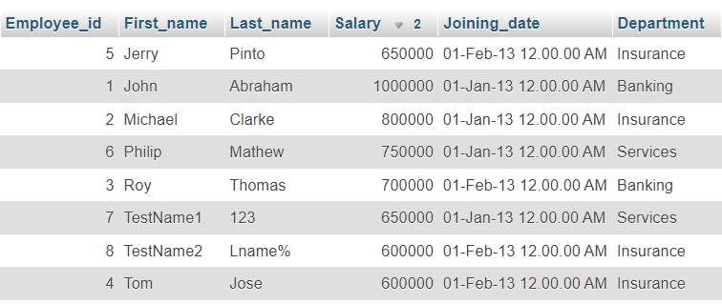

6. Get employee details from employee table whose first name contains ‘J’.

Ans:



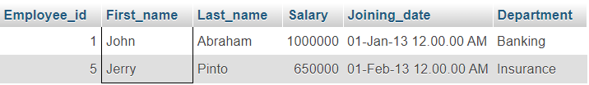

7. Get department wise maximum salary from employee table order by salary ascending?

Ans: 

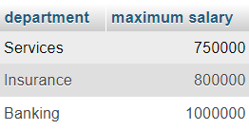

9. Select first_name, incentive amount from employee and incentives table for those employees who have incentives and incentive amount greater than 3000.

Ans:



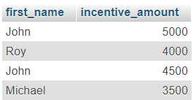

10. Create After Insert trigger on Employee table which insert records in view table.

Ans:

* Create View_table Table Queries

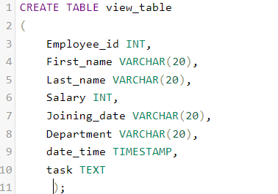

* Trigger Queries

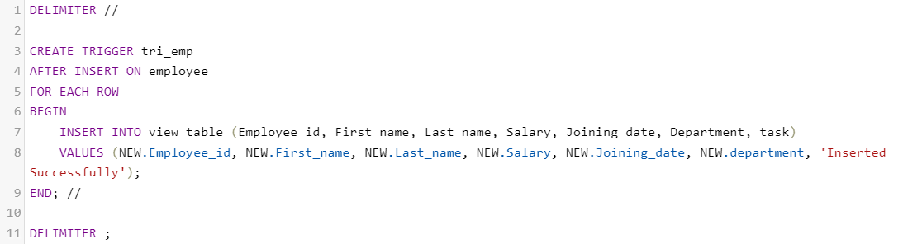



11.Create table given below: Salesperson and Customer

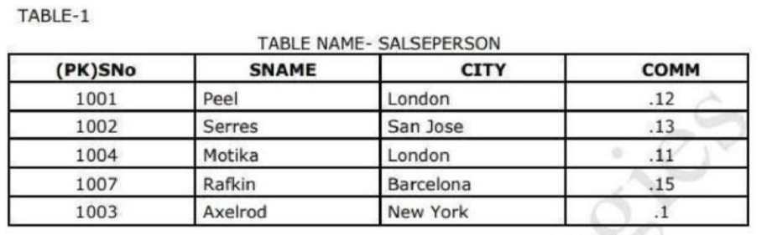

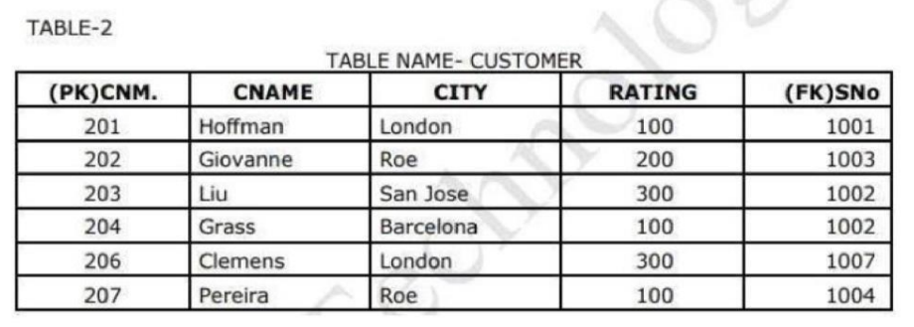

* Create Salse person Table Queries

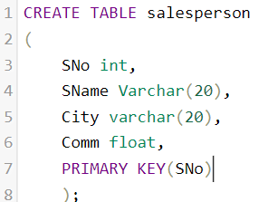

* Create Customer Table Queries

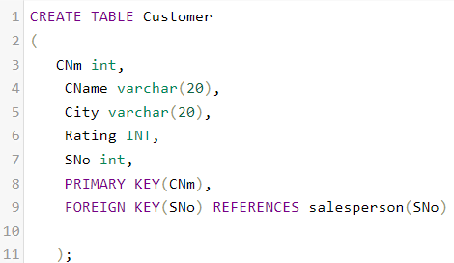

* Salse person Insert Query

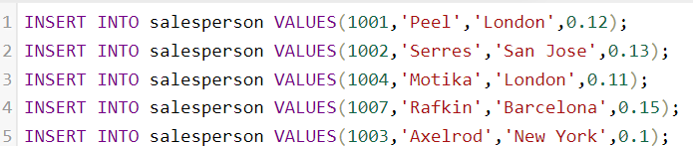

* Customer Insert Query

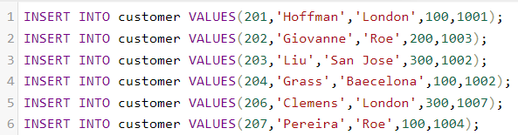

* Salse person Table

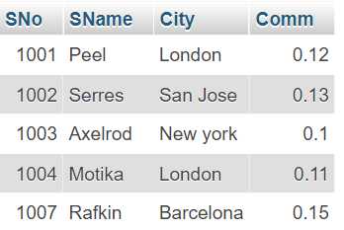

* Customer Table

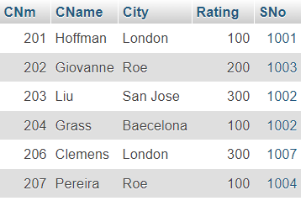

13.All Customer name whose rating is more than 100

Ans:



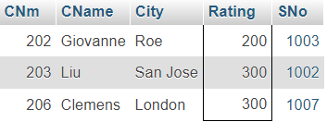

14.Names and cities of all salespeople in London with commission above 0.12

Ans:

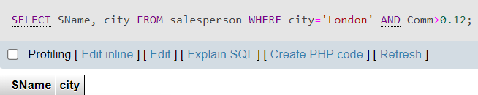

15.All salespeople either in Barcelona or in London



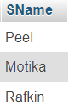

16.All salespeople with commission between 0.10 and 0.12. (Boundary values should be excluded).

Ans:



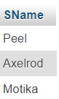

17.All customers excluding those with rating <= 100 unless they are located in Rome

Ans:



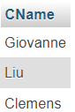

18. Write a SQL statement that displays all the information about all sales people

* Create sales people Table Queries

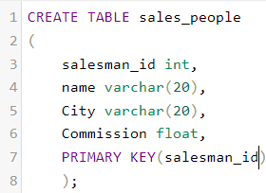

* Insert Sales people Table Queries

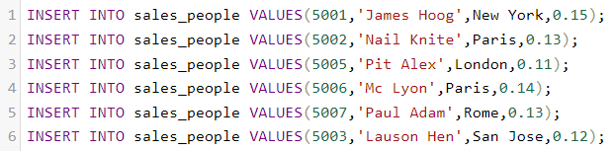

* Sales people Table

Ans:



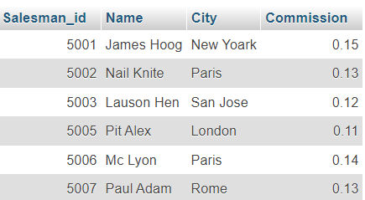

19. From the following table, write a SQL query to find orders that are delivered by a salesperson with ID. 5001. Return ord_no, ord_date, purch_amt.

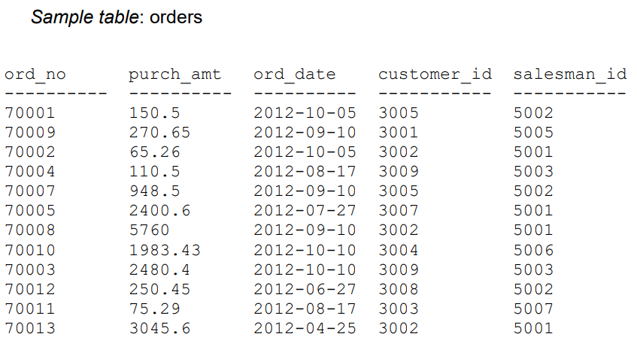

* Create Orders Table Queries

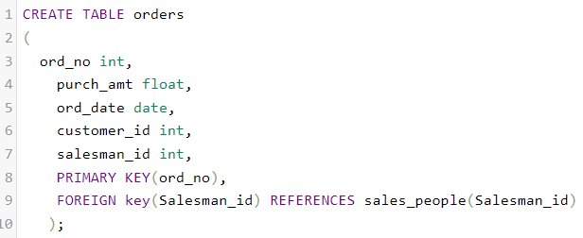

* Insert Orders Table Queries

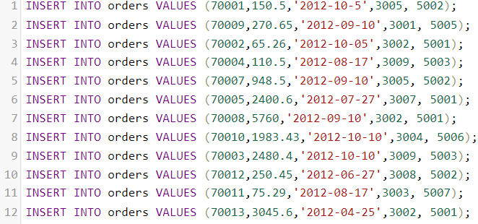

* Orders Table

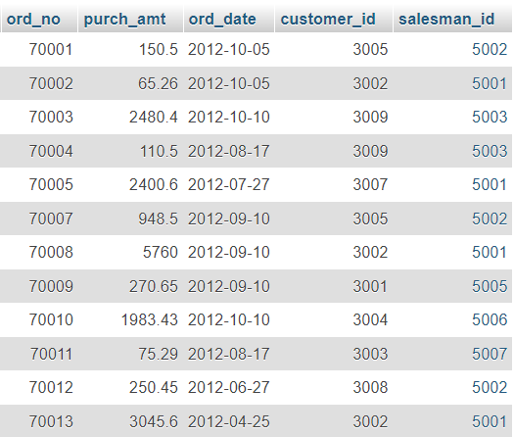

Ans:



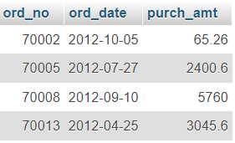

20. From the following table, write a SQL query to select a range of products whose price is in the range Rs.200 to Rs.600. Begin and end values are included. Return pro_id, pro_name, pro_price, and pro_com.

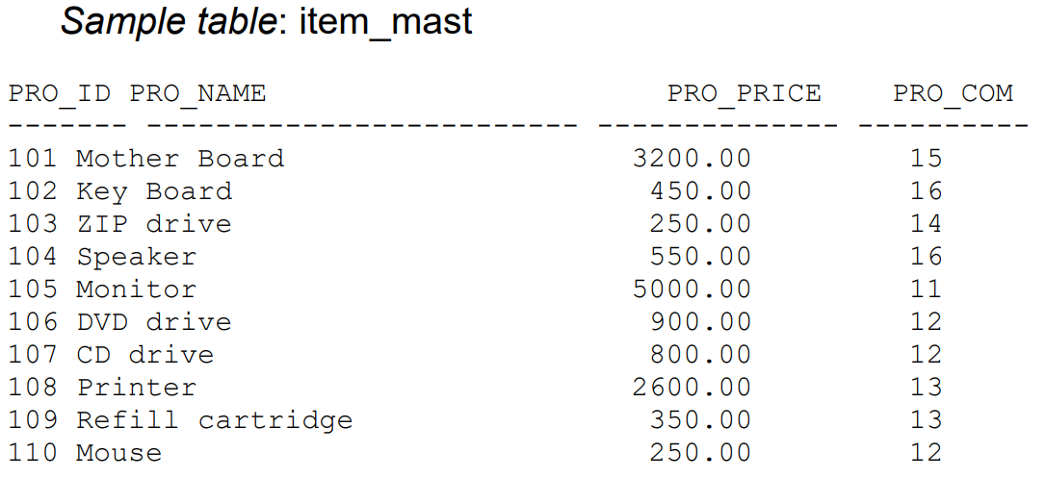

* Create item_mast Table Queries

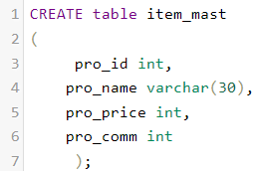

* Insert item_mast Table Queries

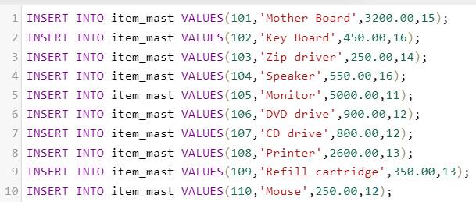

* item_mast Table

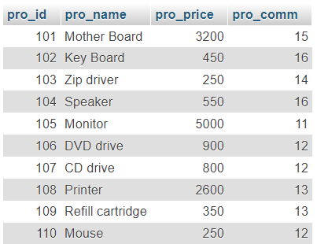

20 Ans:



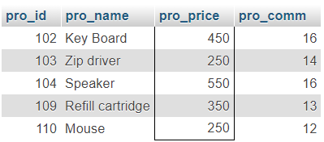

21. From the following table, write a SQL query to calculate the average price for a manufacturer code of 16. Return avg.

Ans:



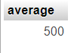

22. From the following table, write a SQL query to display the pro_name as 'Item Name' and pro_priceas 'Price in Rs.

Ans:



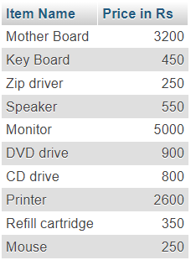

23. From the following table, write a SQL query to find the items whose prices are higher than or equal to $250. Order the result by product price in descending, then product name in ascending. Return pro_name and pro_price.

Ans:



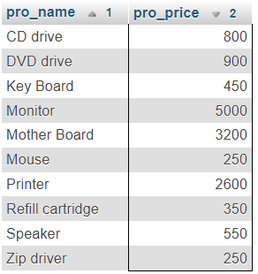

24. From the following table, write a SQL query to calculate average price of the items for each company. Return average price and company code.

Ans:



